1. Introduction
   1. Purpose

This document provides structure of database, code design and file structure of system including internal file structure as well as internal file structure. Developer and tester will base on this design to implement and unit test.

* 1. Definitions, acronyms and abbreviations

|  |  |  |
| --- | --- | --- |
| Abbreviations | Description | Comment |
| ERD | Entity Relation Diagram |  |

* 1. References

|  |  |
| --- | --- |
| Document Number | Title |
| 1 | Screen design document |
| 2 | Architecture design document |

* 1. Overview
     + - Document introduction.
       - Database detail.
       - File design.
       - Code design.
       - Other considerations.

1. Database
   1. ERD

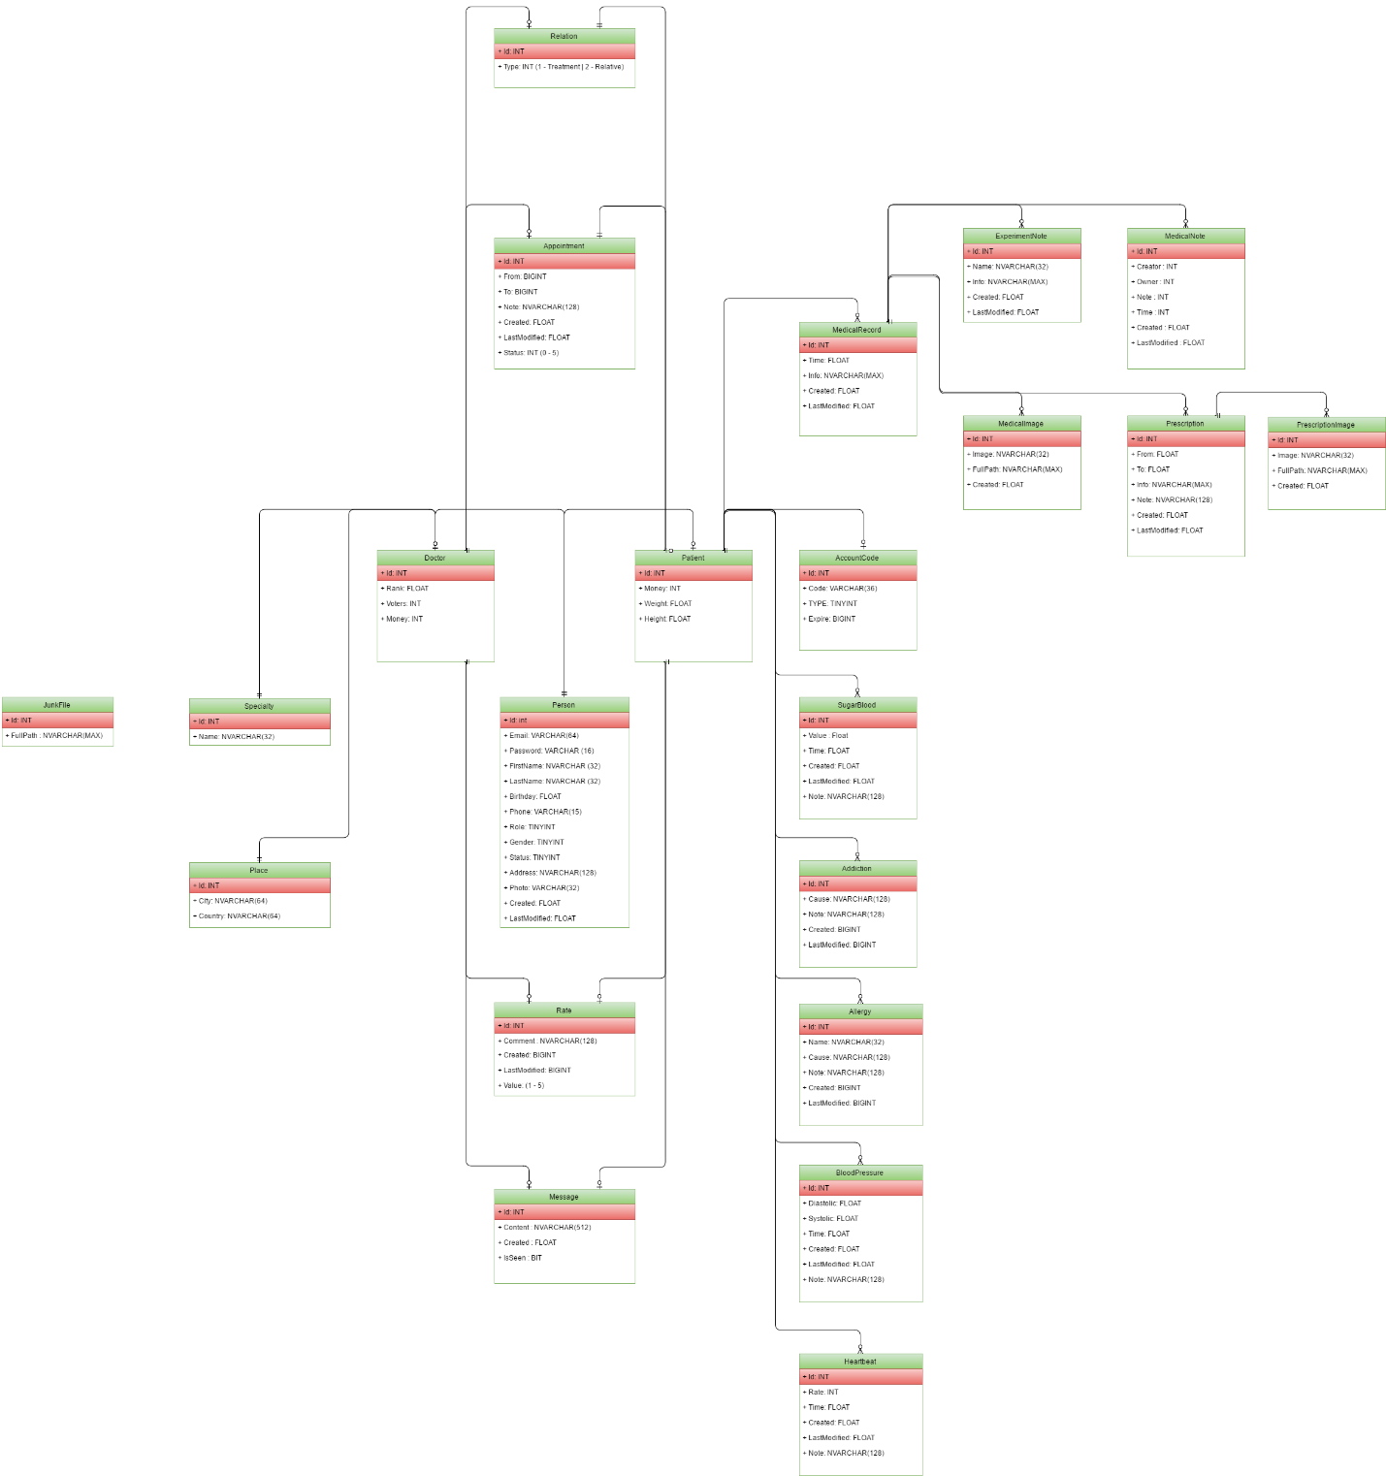

|  |  |  |
| --- | --- | --- |
| No | Table name | Description |
| 1 | JunkFile | Stores information of path of file which should be deleted automatically by server background tasks. |
| 2 | Specialty | Stores information of specialties which belong to a specific doctor. |
| 3 | Place | Stores information of cities and countries where doctor lives or works. |
| 4 | Doctor | Stores information of doctors who have taken part in system. |
| 5 | Relation | Stores information of relationship between patients and doctors. |
| 6 | Appointment | Stores information of appointments which are made by doctors or patients. |
| 7 | Person | Stores information of people who have taken part in system, this table include : Administrators, doctors and patients. |
| 8 | Rate | Stores information of rating points, who made ratings and who were rated. |
| 9 | Message | Stores information of message which have been transfered between patients and doctors. |
| 10 | Patient | Stores information of patients who have taken part in the system. |
| 11 | MedicalRecord | Stores information of medical records which have been created by doctors or patients. |
| 12 | AccountCode | Stores information of tokens which are used for account activation purposes. |
| 13 | SugarBlood | Stores information blood sugar levels which are recorded everyday by patients. |
| 14 | Addiction | Stores information of addiction which are noted by patients. |
| 15 | Allergy | Stores information of allergies which are noted by patients. |
| 16 | BloodPressure | Stores blood pressure information which are noted by patients. |
| 17 | Heartbeat | Stores daily heart rate records which are noted by patients. |
| 18 | ExperimentNote | Stores information of experiment which doctors care about. |
| 19 | MedicalImage | Stores record with image information of medical record. |
| 20 | MedicalNote | Stores notes of medical record. |
| 21 | Prescription | Stores prescriptions which are prescripted to patients in a medical records. |
| 22 | PrescriptionImage | Stores image with information of a prescription. |
| 23 | Diary | Stores personal notes of doctors. |

* 1. Tables
     1. JunkFile

|  |  |  |  |  |  |
| --- | --- | --- | --- | --- | --- |
| No | Field name | Type | Nullable | Primary key | Description |
| 1 | **Id** | INTEGER |  | X | * Unique id of junk file record. |
| 2 | **FullPath** | NVARCHAR(MAX) |  |  | * Full path of file which is used for searching and deleting file. |

* + 1. Specialty

|  |  |  |  |  |  |
| --- | --- | --- | --- | --- | --- |
| No | Field name | Type | Nullable | Primary key | Description |
| 1 | **Id** | INTEGER |  | X | * Unique id of specialty. |
| 2 | **Name** | NVARCHAR(32) |  |  | * Name of specialty. |

* + 1. Place

|  |  |  |  |  |  |
| --- | --- | --- | --- | --- | --- |
| No | Field name | Type | Nullable | Primary key | Description |
| 1 | **Id** | INTEGER |  | X | * Unique id of place. |
| 2 | **City** | NVARCHAR(64) |  |  | * Name of city. |
| 3 | **Country** | NVARCHAR(64) |  |  | * Name of country where city is located. |

* + 1. Doctor

|  |  |  |  |  |  |
| --- | --- | --- | --- | --- | --- |
| No | Field name | Type | Nullable | Primary key | Description |
| 1 | **Id** | INTEGER |  | X | * Unique id of doctor. |
| 2 | **Rank** | FLOAT |  |  | * Rank of doctor which is calculated by voters and points. |
| 3 | **Voters** | INTEGER |  |  | * Number of people who voted for the doctor. |

* + 1. Relation

|  |  |  |  |  |  |
| --- | --- | --- | --- | --- | --- |
| No | Field name | Type | Nullable | Primary key | Description |
| 1 | **Id** | INTEGER |  | X | * Unique id of relationship. |
| 2 | **Created** | FLOAT |  |  | * Time when the relationship was made. |
| 3 | **Status** | TINYINT |  |  | * Current status of relationship (pending / active). |

* + 1. Appointment

|  |  |  |  |  |  |
| --- | --- | --- | --- | --- | --- |
| No | Field name | Type | Nullable | Primary key | Description |
| 1 | **Id** | INTEGER |  | X | * Unique id of appointment. |
| 2 | **From** | FLOAT |  |  | * Time when the appointment starts. |
| 3 | **To** | FLOAT |  |  | * Time when the appointment should be ended. |
| 4 | **Note** | NVARCHAR(128) |  |  | * Note of appointment. |
| 5 | **LastModifiedNote** | NVARCHAR(128) | X |  | * Note of appointment modify action. |
| 6 | **Created** | FLOAT |  |  | * When the appointment was created. |
| 7 | **LastModified** | FLOAT | X |  | * When the appointment was lastly modified. |
| 8 | **Status** | TINYINT |  |  | * Current status of appointment (pending/active/cancelled/..) |

* + 1. Person

|  |  |  |  |  |  |
| --- | --- | --- | --- | --- | --- |
| No | Field name | Type | Nullable | Primary key | Description |
| 1 | **Id** | INTEGER |  | X | * Unique id of person. |
| 2 | **Email** | VARCHAR(64) |  |  | * Email which is used for registering account in the system. Emails must be unique and used as account name. |
| 3 | **Password** | VARCHAR(16) |  |  | * Password of account. |
| 4 | **FirstName** | NVARCHAR(32) |  |  | * First name of person which can be used for display. |
| 5 | **LastName** | NVARCHAR(32) |  |  | * Last name of person which can be used for display. |
| 6 | **Birthday** | FLOAT | X |  | * Time when person was born. |
| 7 | **Phone** | VARCHAR(64) | X |  | * Phone number the person is used for working or contacting. |
| 8 | **Role** | TINTYINT |  |  | * Role of this person in the system (admin/doctor/patient). |
| 9 | **Gender** | TINYINT | X |  | * Gender of person. |
| 10 | **Status** | TINYINT |  |  | * Current status of account (disabled/pending/active). |
| 11 | **Address** | NVARCHAR(128) | X |  | * Address where person lives or works. |
| 12 | **Photo** | VARCHAR(32) |  |  | * Name of photo image file person uses as an avatar. |
| 13 | **Created** | FLOAT |  |  | * When the account was created. |
| 14 | **LastModified** | FLOAT |  |  | * When the account was lastly modified. |

* + 1. Rate

|  |  |  |  |  |  |
| --- | --- | --- | --- | --- | --- |
| No | Field name | Type | Nullable | Primary key | Description |
| 1 | **Id** | INTEGER |  | X | * Unique id of person. |
| 2 | **Comment** | NVARCHAR(128) | X |  | * Comment made by patient when he/she made rating to a doctor. |
| 3 | **Created** | FLOAT |  |  | * When the rating was made. |
| 4 | **Value** | TINYINT |  |  | * Rating point. |

* + 1. Message

|  |  |  |  |  |  |
| --- | --- | --- | --- | --- | --- |
| No | Field name | Type | Nullable | Primary key | Description |
| 1 | **Id** | INTEGER |  | X | * Unique id of message. |
| 2 | **Content** | NVARCHAR(512) |  |  | * Content of message. |
| 3 | **Created** | FLOAT |  |  | * When the rating was made. |
| 4 | **IsSeen** | BIT |  |  | * Whether message has been seen by recipient or not. |

* + 1. Patient

|  |  |  |  |  |  |
| --- | --- | --- | --- | --- | --- |
| No | Field name | Type | Nullable | Primary key | Description |
| 1 | **Id** | INTEGER |  | X | * Unique id of patient. |
| 2 | **Weight** | FLOAT | X |  | * Weight of patient. |
| 3 | **Height** | FLOAT | X |  | * Height of patient. |

* + 1. Medical record

|  |  |  |  |  |  |
| --- | --- | --- | --- | --- | --- |
| No | Field name | Type | Nullable | Primary key | Description |
| 1 | **Id** | INTEGER |  | X | * Unique id of medical record. |
| 2 | **Time** | FLOAT |  |  | * Time which the medical record notes about. |
| 3 | **Info** | NVARCHAR(MAX) | X |  | * Necessary information which is needed attention. |
| 4 | **Created** | FLOAT |  |  | * When the medical record was created. |
| 5 | **LastModified** | FLOAT | X |  | * Time when the medical record was lastly modified. |

* + 1. Account code

|  |  |  |  |  |  |
| --- | --- | --- | --- | --- | --- |
| No | Field name | Type | Nullable | Primary key | Description |
| 1 | **Id** | INTEGER |  | X | * Unique id of account code. |
| 2 | **Code** | VARCHAR(36) |  |  | * Token which is used for reseting password . |
| 3 | **Type** | TINYINT |  |  | * What is the token about (resetting password/activating account). |
| 4 | **Expire** | FLOAT |  |  | * When the token should be expired. |

* + 1. SugarBlood

|  |  |  |  |  |  |
| --- | --- | --- | --- | --- | --- |
| No | Field name | Type | Nullable | Primary key | Description |
| 1 | **Id** | INTEGER |  | X | * Unique id of blood sugar note. |
| 2 | **Value** | FLOAT |  |  | * Sugar blood level at the time measurement was made . |
| 3 | **Time** | FLOAT |  |  | * Time when the measurement was made. |
| 4 | **Created** | FLOAT |  |  | * When the note is created on server. |
| 5 | **LastModified** | FLOAT | X |  | * When the note was lastly modified. |

* + 1. Addiction

|  |  |  |  |  |  |
| --- | --- | --- | --- | --- | --- |
| No | Field name | Type | Nullable | Primary key | Description |
| 1 | **Id** | INTEGER |  | X | * Unique id of addiction note. |
| 2 | **Cause** | NVARCHAR(128) |  |  | * What patient is addictive with . |
| 3 | **Note** | NVARCHAR(128) |  |  | * Time when the measurement was made. |
| 4 | **Created** | FLOAT |  |  | * When the note is created on server. |
| 5 | **LastModified** | FLOAT | X |  | * When the note was lastly modified. |

* + 1. Allergy

|  |  |  |  |  |  |
| --- | --- | --- | --- | --- | --- |
| No | Field name | Type | Nullable | Primary key | Description |
| 1 | **Id** | INTEGER |  | X | * Unique id of allergy. |
| 2 | **Name** | NVARCHAR(32) |  |  | * Name of allergy note. |
| 3 | **Note** | NVARCHAR(128) |  |  | * Which patient is allergic with. |
| 4 | **Created** | FLOAT |  |  | * When the note was submitted to server. |
| 5 | **LastModified** | FLOAT | X |  | * When the note was lastly modified. |

* + 1. BloodPressure

|  |  |  |  |  |  |
| --- | --- | --- | --- | --- | --- |
| No | Field name | Type | Nullable | Primary key | Description |
| 1 | **Id** | INTEGER |  | X | * Unique id of blood pressure record. |
| 2 | **Diastolic** | FLOAT |  |  | * Diastolic information. |
| 3 | **Systolic** | FLOAT |  |  | * Systolic information. |
| 4 | **Note** | NVARCHAR(128) | X |  | * Note of blood pressure measurement. |
| 5 | **Time** | FLOAT |  |  | * Time when the measurement was created. |
| 6 | **Created** | FLOAT |  |  | * When the note was submitted to server. |
| 7 | **LastModified** | FLOAT | X |  | * When the note was lastly modified. |

* + 1. Hearbeat

|  |  |  |  |  |  |
| --- | --- | --- | --- | --- | --- |
| No | Field name | Type | Nullable | Primary key | Description |
| 1 | **Id** | INTEGER |  | X | * Unique id of heart rate measurement record. |
| 2 | **Rate** | FLOAT |  |  | * Rate of heart when the measurement was made. |
| 3 | **Time** | FLOAT |  |  | * Time when the measurement was done. |
| 4 | **Note** | NVARCHAR(128) | X |  | * Note about the measurement. |
| 5 | **Created** | FLOAT |  |  | * Time when the measurement was submitted to server. |
| 7 | **LastModified** | FLOAT | X |  | * When the note was lastly modified. |

* + 1. ExperimentNote

|  |  |  |  |  |  |
| --- | --- | --- | --- | --- | --- |
| No | Field name | Type | Nullable | Primary key | Description |
| 1 | **Id** | INTEGER |  | X | * Unique id of experiment note. |
| 2 | **Name** | FLOAT |  |  | * Name of record. |
| 3 | **Info** | FLOAT |  |  | * Serialized key-value information of experiment. |
| 5 | **Created** | FLOAT |  |  | * Time when the measurement was submitted to server. |
| 7 | **LastModified** | FLOAT | X |  | * When the note was lastly modified. |

* + 1. MedicalImage

|  |  |  |  |  |  |
| --- | --- | --- | --- | --- | --- |
| No | Field name | Type | Nullable | Primary key | Description |
| 1 | **Id** | INTEGER |  | X | * Unique ID of medical image record. |
| 2 | **Image** | FLOAT |  |  | * Image file name. |
| 3 | **FullPath** | FLOAT |  |  | * Physical path of image. |
| 5 | **Created** | FLOAT |  |  | * Time when the image was lastly modified in server. |

* + 1. MedicalNote

|  |  |  |  |  |  |
| --- | --- | --- | --- | --- | --- |
| No | Field name | Type | Nullable | Primary key | Description |
| 1 | **Id** | INTEGER |  | X | * Unique ID of medical note. |
| 2 | **Note** | NVARCHAR(128) |  |  | * Note information. |
| 3 | **Time** | FLOAT |  |  | * Time which note is about. |
| 5 | **Created** | FLOAT |  |  | * Time when the record was submitted to server. |
| 6 | **LastModified** | FLOAT |  |  | * Time when the image was lastly modified in server. |

* + 1. Prescription

|  |  |  |  |  |  |
| --- | --- | --- | --- | --- | --- |
| No | Field name | Type | Nullable | Primary key | Description |
| 1 | **Id** | INTEGER |  | X | * Unique ID of prescription. |
| 2 | **From** | FLOAT |  |  | * Time when the prescription should be available |
| 3 | **To** | FLOAT |  |  | * Time when the prescription should be unavailable. |
| 5 | **Name** | NVARCHAR(32) |  |  | * Name of prescription note. |
| 5 | **Medicine** | NVARCHAR(MAX) | X |  | * Serialized list of medicines which patient should take. |
| 6 | **Note** | NVARCHAR(128) | X |  | * Note of prescription. |
| 7 | **Created** | FLOAT |  |  | * Time when the image was submitted to server. |
| 8 | **LastModified** | FLOAT | X |  | * Time when the image was lastly modified in server. |

* + 1. PrescriptionImage

|  |  |  |  |  |  |
| --- | --- | --- | --- | --- | --- |
| No | Field name | Type | Nullable | Primary key | Description |
| 1 | **Id** | INTEGER |  | X | * Unique ID of prescription. |
| 2 | **Image** | NVARCHAR(32) |  |  | * Name of image. |
| 3 | **FullPath** | NVARCHAR(MAX) |  |  | * Physical path where image is located. |
| 4 | **Created** | FLOAT |  |  | * Time when the image was uploaded to server. |